Use case: Login in public part of the system

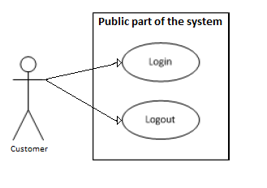

| Name | Login in the public part of the system |
| --- | --- |
| Summary | This use case describes how an actor can login in public part in the system |
| Goal | 1. The user has an account  2. The user wants to login  3. The user is not already logged in |
| Actor | User |
| Preconditions | The actor is on login form |
| Basic Flow | 1. The user open login page  2. The system display login page  3. The user enter email  4. The user enter password  5. The user click login button  6. The system check for valid credentials  7. The system redirect user to the profile page. |
| Alternative flows | 1. The user open login page  2. The system display login page  3. The user enter email  4. The user enter password  5. The user click login button  6. The system check for valid credentials and check fails  7. The system display error message indicating invalid log and allows the user to log again. |
| Post conditions | 1. The user is logged in to the system  2. The user has access to the functions of public part of the system |

Use case: Logout of public part of the system

| Name | Logout of public part of the system |
| --- | --- |
| Summary | This use case describes how an actor can logout of public part of the system |
| Goal | The user wants to logout of his/her profile on system |
| Actor | User |
| Preconditions | 1. The actor is logged in  2. The actor no longer wants to be logged in |
| Basic Flow | 1. The user is done with using the system  2. The click on logout link  3. The system display successful logout message |
| Alternative flows | N/A |
| Post conditions | The user successfully logout of the system |

Use case: Login in private part of the system

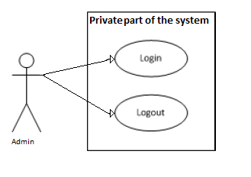

| Name | Login in the private part of system |
| --- | --- |
| Summary | This use case describes how an admin can login in private part of the system |
| Goal | 1. The admin has an account  2. The admin wants to login  3. The admin is not already logged in |
| Actor | Admin |
| Preconditions | The actor is on admin login form |
| Basic Flow | 1. The admin open login page of administration page  2. The system display login page  3. The admin enter email  4. The admin enter password  5. The admin click login button  6. The system check for valid credentials  7. The system redirect user to the appropriate home page. |
| Alternative flows | 1. The user open login page  2. The system display login page  3. The user enter email  4. The user enter password  5. The user click login button  6. The system check for valid credentials and check fails  7. The system display error message indicating invalid log and allows the user to log again. |
| Post conditions | 1. The admin is logged in to the private part of the system  2. The user has access to the functions of private part of the system |

Use case: Logout of private part of the system

| Name | Logout of private part of the system |
| --- | --- |
| Summary | This use case describes how an actor can logout of private part of the system |
| Goal | The admin wants to logout of his/her profile on system |
| Actor | Admin |
| Preconditions | 1. The actor is logged in  2. The actor no longer wants to be logged in |
| Basic Flow | 1. The admin is done with using the system  2. The click on logout link  3. The system display successful logout message |
| Alternative flows | N/A |
| Post conditions | The admin successfully logout of the system |